RAID Theory

RAID Concepts
The overall goal of RAID is to provide enhanced performance and reliability over a single disk drive by combining a number of physical drives into a logical array of drives. As the name implies, the array stores redundant information about the data to provide protection for the data in the event of disk failure.
RAID addresses the problems associated with high-volume storage requirements. When the volume of data requires a large number of drives for storage, there is an increased chance of drive failure. Drive failure results in a temporary loss of data, and requires restoration of data from a backup tape. Also, because backup is not typically done on a continuous basis, recently created data may not be recoverable.
In theory, RAID works by creating redundant information about the data in the disk array and then spreading the original data and redundant parity data across the disk array. The spreading of data ensures that only a small part of any given file is lost if a single drive fails. The parts of the file on the other disks in the array plus the parity data are sufficient to reconstruct the data lost on the failed drive.
The possibility of data loss is no longer tied to the failure of a single disk. Common forms of RAID do not lose data until two disks in the array fail at the same time, which is much less likely than a single drive failure.

Fundamental Concepts
Some fundamental concepts must be understood before presenting the details of RAID. These concepts are described within the context of how RAID is applied on Dell systems. Definitions may vary from those used elsewhere in the industry or by other manufacturers. These concepts include:

Array: A disk array is a collection of disk drives that are linked together logically so that they appear to act as a unit. The array controller defines the characteristics of the array. Dell’s current array controller is the PowerEdge Expandable RAID Controller 3 (PERC 3).

Channel: A channel is any path used for the transfer of data and the control of information between storage devices and a storage controller.

Drive size: All drives in any RAID must have the same capacity. If they do not, then the controller logically resizes each drive to the capacity of the smallest drive in the array so that all sizes match.

Stripe: A stripe is the area on a particular disk drive where some part of the data from a file is stored. A stripe can be as small as a sector (512 bytes) or as big as a few megabytes. The controller adjusts the size of a stripe when it configures the array. The nature of the application using the array determines the size of the stripe.

Spanning: Spanning is the combining of disk arrays connected to different SCSI backplanes into a logical unit.

Mirroring: Mirroring is maintaining a duplicate of one disk drive on another disk drive. Mirroring can be combined with striping. Mirroring is the same as RAID 1.

Redundancy: Redundancy is a technique to provide greater data integrity in a RAID array. Redundancy is a backup copy of stored data in the array. This extra information sufficiently describes the data structures in the array so that the arrays can be easily rebuilt in the event of drive failures in the array. The larger the amount of redundant information that is stored, the easier it is to rebuild the array in the event of drive failure.

Storage Capacity: Storage capacity is the total amount of disk space in the array. If an array has four 9-GB drives, the total storage capacity is 36 GB.

Storage Efficiency: Storage efficiency is the percentage of the total storage capacity that can contain unique data. For mirroring, storage efficiency is 50 percent because one byte of data occupies a byte of storage space on each of two drives in an array. In an array of four 9-GB disks with disk mirroring, only 18 GB of space is available for storage. Therefore, the storage efficiency is 50 percent. Generally, the greater the redundancy, the lower the efficiency of the array.

Parity: Parity is a mathematical method that allows a small amount of data to provide “backup” or protection for a large amount of data. It is based on a simple Boolean logic operation over the data stored across stripes in a RAID. The result of the parity calculation is the redundant information used to restore data when a drive failure occurs. Parity is calculated whenever data is written to a RAID. If a disk fails, then the same parity operation calculated on the remaining data and parity stripes in the array reconstructs the data on the failed disk’s stripe.

RAID Implementations: Hardware Versus Software
A hardware RAID delivers better performance than a software RAID because the RAID controller’s processor frees the system processor and provides balanced higher performance.
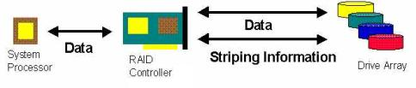
Figure 1: Hardware RAID with a Dedicated RAID Controller

A hardware RAID does not require the intervention of the operating system. This allows applications to run faster. The system processor communicates with the RAID controller as if it were a normal disk drive. The processor in the RAID controller acts like a parallel processor dedicated to I/O.
Because the dedicated processor on the RAID controller handles the striping information, these commands are executed quicker. They do not have to be passed from the system processor to the drive controller.
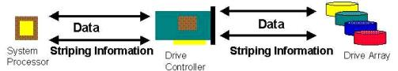
Figure 2: Software RAID with a standard drive controller

A software RAID requires the system processor to perform all the RAID functions. This slows down the system’s overall performance. The processor must generate the striping information along with the data being accessed in the drive array.

RAID Levels
The RAID Advisory Board (RAB) is responsible for issuing definitive statements regarding RAID levels. Most of the industry still uses these numbered RAID levels. The Dell PowerEdge Expandable RAID Controller (PERC) supports RAID Levels 0, 1, 3, 5, and the combined Level 10. The Dell PowerEdge Expandable RAID Controller 2 (PERC 3) supports RAID Levels 0, 1, 5, and the combined Level 10.

RAID 0

RAID 0 was never sanctioned by the RAID Advisory Board (RAB). RAID 0 is an independent array without parity redundancy that accesses data across all drives in the array in a block format. This configuration produces very high performance for single file I/O and also uses 100 percent of the drive storage capacity for storing data. To accomplish this,the first data block is read from, or written to, the first disk in the array. The second block, meanwhile, is read from/written to the second disk and so on. RAID 0 only addresses improved data throughput, disk capacity and disk performance. It is good for applications that have large file sizes and high performance requirements, such as digital video. The 100-percent storage efficiency means that all of the data storage available on the array drives is used to store data. However, this approach offers no means of recovery from a failure. If a single drive is lost the contents of the entire array is lost. The failure rate of RAID 0 increases with the number of drives in the array.
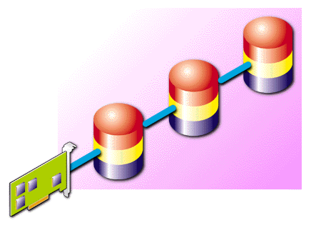
RAID 0: Striping across three independent disks.

RAID 1

RAID 1 is drive mirroring or disk mirroring. As data is written to the primary drive, the RAID controller copies identical data to a second drive, called the mirroring drive. In addition, these drives can be on separate controllers. Using separate controllers, called duplexing, provides for protection against controller failure as well as against disk failure. Mirroring delivers excellent data protection because both of the drives in a level 1 RAID must fail before data is certain to be lost. However, there must be twice as much disk space as there is data to store, which becomes rather expensive for large amounts of data. Use RAID 1 when the loss of even a small amount of data is unacceptable.
RAID 1 can be optimized to provide better data-read performance than with a single disk. Performance is hardly affected even if a mirrored drive fails. The main disadvantage of RAID 1 is the need to buy twice the drive storage capacity to meet storage requirements.
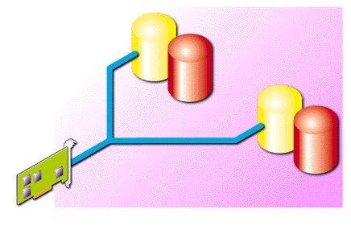
RAID 1: Controller Sends Duplicated Data to Mirroring Disk.

RAID 3

RAID 3 spreads the data from a file across the drives in the array (similar to RAID 0). The RAID controller subdivides the file into pieces the size of a stripe in a stripe set, which facilitates parallel access to the parts of the file. The controller then simultaneously writes the pieces of the file to the destination stripes. The controller fills stripes until the file is completely stored. As the controller writes each group of stripes, it calculates a parity stripe and writes it to a drive that is dedicated to storing the parity information. If any one of the disks should fail, the information on the remaining disks is sufficient to reconstruct the information on the failed disk. RAID 3 offers greater storage efficiency than RAID 1 while still providing protection for the data. RAID 3 is often referred to as Striping With Dedicated Parity. With the minimum three drives needed for RAID 3, the storage efficiency is 66 percent. With six drives, the storage efficiency is 87 percent. The main disadvantage to RAID 3 is poor performance for multiple, simultaneous, and independent read/write operations.
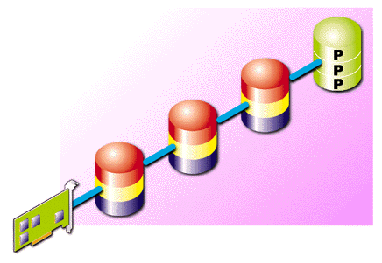
RAID 3: Controller calculates parity stripe from three data stripes and stores them all in parallel on synched drives.

RAID 5

RAID 5 has some similarities to RAID 3. RAID 5 spreads the data from a file across different stripe sets in much the same manner as RAID 3. RAID 5 similarly calculates and writes a parity stripe. The major difference is that the parity is spread across the array in a manner similar to the data. Multiple independent accesses of the files on the array are optimized over RAID 3. Distributing the parity over the drives in the array distributes the workload for parity operations over the entire array. This is an improvement over RAID 3, where any write operation guarantees an access of the parity drive. If a RAID 5 array has several simultaneous and independent write operations, several simultaneous parity calculations could take place. If the parity information is all stored on one disk, then there will be contention at the parity drive while the parities are written. Spreading the parity across the array helps prevent this contention. RAID 5 is often referred to as Striping With Distributive Parity. The storage efficiency of RAID 5 is like that of RAID 3. For a typical Dell PERC 2 configuration, efficiency can range from 66 percent to 87 percent, for arrays with three to six drives, respectively. The main disadvantage of RAID 5 is that a write operation takes much longer than a read operation. The write operation takes longer because even a small write into a single stripe requires that all of the stripes on the other disks be read to recalculate the parity. RAID 5 is the industry norm.
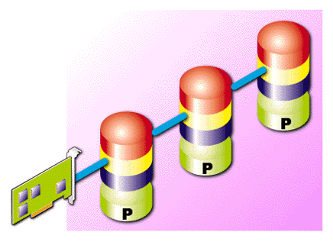
RAID 5: Controller calculates a parity stripe from three data stripes and interleaves these on the disks.

RAID 10

RAID 10 is a de facto RAID level that was never sanctioned by the RAB. It is common to combine the basic RAID levels to produce a configuration that is more appropriate to a system’s specific I/O requirements. RAID 10 is a combination of RAID 1 with RAID 0. An array of drives is setup as RAID 1 for maximum fault tolerance. This array is then treated like a single drive and striped with an identical array in a RAID 0 configuration. The resulting striped array can continue to operate even if a single drive fails. Note that the drives in one RAID 1 pair can be of different sizes. However, each RAID 1 array should be identical to the other RAID 1 array. RAID 10 has excellent single file I/O performance, with the same fault tolerance as RAID 1. This combination RAID level has the same 50 percent storage efficiency as RAID 1. A RAID 10 configuration requires a minimum of four disks. Organizations such as hospitals or the IRS use RAID Level 10 because data integrity and accessibility are more important than storage efficiency and cost.
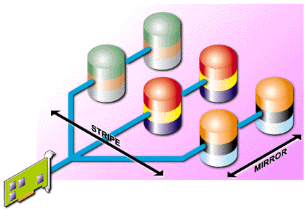
RAID 10: Three Level 1 RAIDs striped together as a RAID 0.

RAID 50

RAID 50 was also never sanctioned by the RAID Advisory Board (RAB). It is common to combine the basic RAID levels to produce a configuration that is more appropriate to a system's specific I/O requirements. Although there has yet to be a standard initiated this is how the PERC Controllers handle RAID 10 and RAID 50.
RAID 50 provides the features of both RAID 0 and RAID 5. RAID 50 includes both parity and disk striping across multiple drives. RAID 50 is best implemented on two RAID 5 disk arrays with data striped across both disk arrays. RAID 50 breaks up data into smaller blocks, and then stripes the blocks of data to each RAID 5 disk set. RAID 5 breaks up data into smaller blocks, calculates parity by performing an exclusive-or on the blocks, and then writes the blocks of data and parity to each drive in the array. The Size of each block is determined by the stripe size parameter, which is set during the creation of the RAID set.
RAID 50 can sustain one to eight drive failures while maintaining data integrity if each failed disk is in a different RAID 5 array.
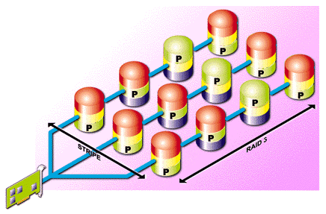
RAID 50: Four Level 5 RAIDs striped together as a RAID 0.

